SUMMARY OF PRODUCT CHARACTERISTICS

1. NAME OF THE VETERINARY MEDICINAL PRODUCT

Startect Dual Active Oral Solution for Sheep

2. QUALITATIVE AND QUANTITATIVE COMPOSITION

Each ml contains:

Active Substances
Derquantel 10 mg/ml
Abamectin 1.0 mg/ml

Excipients
Butylated hydroxytoluene 0.5 mg/ml

For a full list of excipients, see Section 6.1.

3. PHARMACEUTICAL FORM

Oral Solution
A clear to hazy, colourless to yellow-brown solution.

4. CLINICAL PARTICULARS

4.1 Target species

Sheep

4.2 Indications for use, specifying the target species
STARTECT Dual Active is a broad spectrum anthelmintic for the treatment and control of mixed gastro-intestinal nematode infections and associated diseases of sheep. The spectrum of activity is as follows:

Adult and Immature Gastro-intestinal Nematodes:

Haemonchus contortus (including inhibited larval stages)
Teladorsagia (Ostertagia) circumcincta (including inhibited larval stages)
Teladorsagia (Ostertagia) trifurcata
Trichostrongylus axei
Trichostrongylus colubriformis
Trichostrongylus vitrinus
Cooperia curticei
Cooperia oncophora
Nematodirus spathiger
Nematodirus filicollis
Nematodirus battus
Strongyloides papillosus
Oesophagostomum venulosum (adult)
Trichuris ovis
Chabertia ovina
Lungworms:
Dictyocaulus filaria (adult)
This product is effective against strains of parasites resistant to benzimidazoles, levamisole, macrocyclic lactones, and combinations of these.

4.3 Contraindications

Do not use in dogs as severe adverse reactions may occur.
Do not use in horses as severe adverse reactions, including fatalities, will occur.
Do not exceed the recommended dose rate.

4.4 Special warnings for each target species

Care should be taken to avoid the following practices because they increase the risk of development of resistance and could ultimately result in ineffective therapy:
- Underdosing, which may be due to underestimation of bodyweight, misadministration of the product or lack of calibration of the dosing device.
- Too frequent and repeated use of anthelmintics from the same class over an extended period of time.
Assess bodyweight as accurately as possible before calculating dosage. Suspected clinical cases of resistance should be further investigated using the appropriate tests, e.g. (Faecal Egg Count Reduction Test). Where the results of the test(s) strongly suggest resistance to a particular anthelmintic, an anthelmintic belonging to another pharmacological class and having a different mode of action should be used.

4.5 Special precautions for use

- Special precautions for use in sheep

The recommended dose of STARTECT Dual Active is 0.2 ml/kg; doses of 0.9 ml/kg and higher (4.5X the recommended dose) can cause signs of toxicity and may lead to fatalities.
If animals are batched for dosing it is very important that careful consideration be given to the weight range within each group, to avoid the risk of overdosing smaller animals. A representative sample of animals should be weighed before treatment.
Accuracy and proper functioning of the dosage device should be checked.
The safety of STARTECT Dual Active has not been established in sheep under six weeks of age or weighing less than 10 kg.

- Special precautions for the person administering the veterinary medicinal product to animals

Do not eat, smoke or drink while handling the product.
Wear impermeable rubber gloves during use.
Avoid ingestion, inhalation and eye and skin contact. Wash hands after handling the product. In case of accidental ingestion, seek medical advice immediately. Show package leaflet or label to the physician.
In case of accidental eye or skin contact, wash affected areas immediately with clean running water and seek medical attention if irritation persists.

- Other precautions

4.6 Adverse reactions (frequency and seriousness)

Mild transient coughing is very commonly reported following drenching.

4.7 Use during pregnancy, lactation or lay

The product can be used in pregnant, lactating and breeding animals.
4.8 Interaction with other medicinal products and other forms of interaction

None known.

4.9 Amount(s) to be administered and administration route

STARTECT Dual Active is a ready-to-use oral solution.

The dose for sheep is 2 mg derquantel and 0.2 mg abamectin per kg bodyweight. i.e. 1 ml of product per 5 kg bodyweight.

Drench sheep orally, using a drench gun with silicone sealed ‘o’ rings.
Check dose rates and the accuracy of the drench gun before treatment commences.
Do not under- or over-dose. To ensure administration of a correct dose, body weight should be determined as accurately as possible. If animals are to be treated collectively rather than individually, they should be grouped according to their bodyweight and dosed accordingly.Set the dosing gun to deliver the correct dose volume for the weight of sheep to be treated (see figure 1).

Figure 1
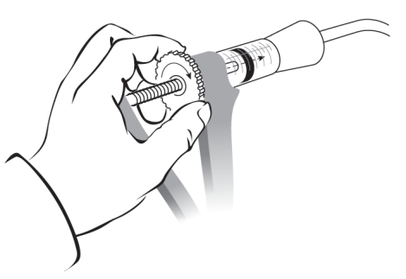

Gently place the nozzle of the drench gun over the back of the tongue and depress the trigger (see figure 2).
Figure 2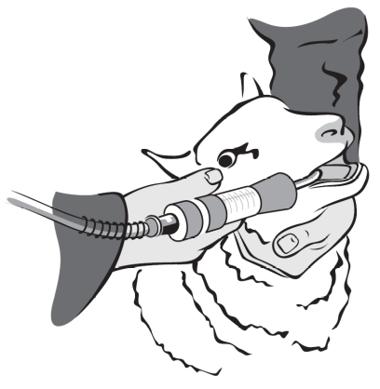

4.10 Overdose (symptoms, emergency procedures, antidotes), if necessary

Doses of 0.9 ml/kg and higher have been associated with symptoms of toxicity. Signs of toxicity include dullness, depression, incoordination, weakness, decreased gastrointestinal motility and abnormal breathing pattern, recumbency and death. Non-fatal adverse events have been shown to be fully reversible. Supportive veterinary care is indicated; there is no known antidote.

4.11 Withdrawal period(s)

Meat and offal: 14 days
Milk: do not use in lactating ewes producing milk for human consumption.

5. PHARMACOLOGICAL PROPERTIES

Pharmacotherapeutic group: Endectocides
ATC Vet Code: QP54AA52

5.1 Pharmacodynamic properties

Derquantel is the first member of the spiroindoles, a novel class of anthelmintics with a different mode of action from existing anthelmintic classes. It acts as an antagonist at nicotinic cholinergic receptors (nAChR). It prevents contraction of somatic muscle in the parasites by blocking ACh-induced activation of cation channels in the muscle membrane. This blockade results in flaccid paralysis in nematodes.
Abamectin is a member of the macrocyclic lactone (ML) family of anthelmintics. Abamectin exerts its anthelmintic effect by binding to glutamate-gated chloride (GluCl) channels expressed on nematode neurones and pharyngeal muscle cells. This leads to an increased permeability of the cell membrane to chloride ions with hyperpolarisation of nerve or muscle cells resulting in paralysis and death of the parasite.

5.2 Pharmacokinetic properties

After a single oral administration of STARTECT Dual Active, maximum concentrations of derquantel of 108 ng/ml were reached at 4.2 h. The terminal t1/2 of derquantel was 9.3 h and the absolute bioavailability was 56.3%. The maximum concentration of abamectin after oral administration of STARTECT Dual Active was 31.1 ng/ml and was reached at 24 h post-dose. The terminal t1/2 of abamectin was 28 h and the absolute bioavailability was 69.7%.
The metabolism of derquantel is extensive and complex. Derquantel undergoes biotransformation to a large number of metabolites over a short time period and as a result, extensive variation in metabolites has been found over tissues and time periods.
Highest concentrations of abamectin were found in liver and fat with much lower concentrations being present in kidney and muscle. By 10 and 14 days the concentrations in many kidney and fat samples were close to or below the limit of detection. Abamectin B_{1a} was the major component in all tissues.

After oral administration, the majority of derquantel is eliminated in the faeces and a smaller part in the urine, while abamectin is almost entirely excreted via the faeces with elimination in urine being negligible.”
Pharmacokinetic studies in sheep have demonstrated that there are no negative interactions between the 2 active principles, derquantel and abamectin, in STARTECT Dual Active.

5.3 Environmental properties

The product is toxic to dung insects. It is excreted mainly in faeces and it cannot be excluded that insects using dung excreted after treatment may be adversely affected. Using the product strictly in accordance with the SPC will keep this risk to a minimum.

6. PHARMACEUTICAL PARTICULARS

6.1 List of excipients

Butylated hydroxytoluene
Glycerol formal
Triacetin
Propylene glycol dicaprylate

6.2 Incompatibilities

Not to be mixed with other veterinary medicinal products before administration.

6.3 Shelf life

Shelf-life of veterinary medicinal product as packaged for sale: 2 years.
Shelf-life after first opening the immediate packaging: 12 months.

6.4 Special precautions for storage

Do not refrigerate or freeze.

6.5 Nature and composition of immediate packaging

Purple square bottom backpack HDPE polymer bottles (1L and 5L) with draw off tubes (white LDPE, tube with EDPM valve) and child resistant lids. Purple jerrycan, (15L) HDPE polymer, with white cap. 15L jerrycan has polypropylene tap with O-ring silicone seal with tamper proof lid.
Pack sizes: 1L, 5L and 15 L multi-dose packs. Not all pack sizes may be marketed.

6.6 Special precautions for the disposal of unused veterinary medicinal product or waste materials derived from the use of such products, if appropriate

Any unused veterinary medicinal product or waste materials derived from such veterinary medicinal products should be disposed of in accordance with local requirements.
Extremely dangerous to fish and aquatic life. Do not contaminate water courses with the product or used container.

7 MARKETING AUTHORISATION HOLDER

Zoetis UK Limited
5th Floor, 6 St. Andrew Street
London
EC4A 3AE.

8. MARKETING AUTHORISATION NUMBER

Vm: 42058/4135

9. DATE OF FIRST AUTHORISATION

Date: 13 January 2012

10. DATE OF REVISION OF THE TEXT

Date: October 2013

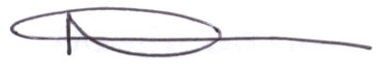05 December 2013

